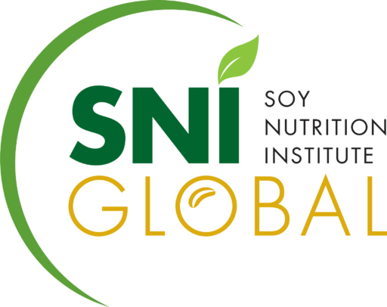

To: Informing the White House Conference on Hunger, Nutrition, and Health Coalition:

Soy Nutrition Institute (SNI) Global is the leading voice representing the science of soy for/to industry producers, suppliers, and users up and down the soy value chain involved with soybeans or soy ingredients intended for human use.

We are pleased the White House is convening the Conference on Hunger, Nutrition, and Health and look forward to participating in the goal of re‐imagining our nation’s food system to end hunger, improve nutrition, and reduce diet-related chronic diseases.

We know the Informing the White House Conference coalition is playing an important role by convening voices from across the nation to help solve the issues at the heart of the Conference. As part of that effort, we wanted to share with you our suggestions across the pillars to help inform your efforts and recommendations.

Improve food access and affordability:
SNI Global supports policies that improve food access and affordability.

One significant way to improve food access is through federal feeding programs. The National School Lunch and Breakfast Programs, Child and Adult Care Feeding Program, Summer Food Service Program, and Women, Infants and Children (WIC) Program, among others, provide nutrition and significant amounts of protein to underserved populations in need. We believe the USDA should adopt policies that gradually increase the amount of soyfoods distributed through these programs, particularly because soyfoods are an excellent source of protein, essential amino acids and other valuable nutrients such. For those interested in dietary patterns that are plant-forward, plant-based, flexitarian, vegan, vegetarian- and more, soy is an important food. Soy is the only widely available plant protein source that is considered complete, meaning it meets the protein needs of children as well as adults.

In order to improve food access, we encourage USDA to eliminate barriers to consuming soy. For example, current National School Lunch Program guidelines require the presentation of a note from a physician or other medical professional before soymilk can be substituted for dairy milk. Considering the widespread prevalence of lactose intolerance, particularly among some specific ethnic populations, this practice is burdensome and unfair, and it also interferes with the growing consumer desire to replace traditional dairy milk for plant-based alternatives for a variety of ethical, religious, or nutrition reasons.

Another example of a way to increase access would be updating the WIC food packages to include soy-based yogurts as a yogurt option, per the 2017 National Academies of Science, Engineering, and Medicine WIC food package update report recommendations. The Federal government is a significant purchaser of food, not only through USDA nutrition programs, but also through large procurements for the Department of Defense and other government organizations. All government funded procurements should adopt policies that encourage greater use to expand access to this complete plant protein source which supports health across the lifespan.

Empower all consumers to make and have access to healthy choices:
SNI Global supports empowering all consumers to make and have access to healthy choices. As consumers increasingly reach for protein from plant sources, soy has become a desirable ingredient for these product formulations because of its functionality, versatility, and high-quality nutrition. Soy is an ingredient that delivers high-quality protein in plant-based beverages and meat alternatives. Soy protein is increasingly being incorporated into products to contribute the essential nutrient protein either as the sole source or in combination with other proteins from animal or plants. Soy protein boosts the nutrition profile and offers environmental benefits. Given their appeal to consumers, plant-based center of plate options, such as soy-based burgers, have a tremendous potential to improve access to healthy choices.

However, some are seeking “standards of identity” to prevent alternative protein producers from using conventional meat and dairy terms on their product labels. In order to empower consumers, plant products should be able to continue to be allowed to utilize the words “milk” and “meat”- particularly if clearly labeled that they are derived from plant-based sources. SNI Global asks the FDA and the broader Administration to codify this as it considers draft guidance on plant-based milks and plant-based alternatives, while we continue to promote these healthy choices to empower consumers and improve access to healthy choices.

We also encourage strong recommendations for soyfoods consumption from the upcoming 2025-2030 Dietary Guidelines for Americans as well as robust consumer-friendly messages to follow through MyPlate.

Enhance nutrition and food security research:
SNI Global supports enhancing nutrition and food security research. We believe science-based research studies focused on ways to empower consumers to make healthy choices and increase food security should be pursued by the government.

Moreover, work by the private sector, including studies from the Soy Health and Nutrition Research Program, funded by the United Soybean Board, around priority health outcomes, should be considered. Particularly, we would point the Administration to our research related to processed foods, which has shown that both unprocessed food as well as processed foods can be part of healthy dietary patterns and that nutrient density should be the focus. Processed, even ultra-processed, foods can help Americans incorporate nutrient-dense foods into a healthy dietary pattern. There are many nutritionally comparable ultra-processed foods options to unprocessed or minimally foods. For example, plant-based meat and dairy alternatives can offer similar nutrient profiles to their animal-based counterparts and are often fortified with shortfall nutrients as well as nutrients of particular concern to those adhering to a plant-based diets. Many types of soyfoods are often considered processed, yet they are nutritious, shelf-stable, safe, functional convenient, and taste good.

Incorporating this scientific research – and supporting additional research in this area – further emphasizes the benefits of processed foods and the role they play in enhancing nutrition and food security.

Thank you for the opportunity to share information about the robust efforts of the soy industry to address hunger and nutrition. We welcome further dialogue with your Coalition leading into the September Conference and beyond. We also plan to share this information with leaders at the White House.

